Organ Petting Zoo  “It’s ewwwwwwwwww in a cool way!”  Educational Programs by This Old Farm are Fun and Exciting.  Kids are introduced to………………  - Hands on learning  - Where their food comes from  - Anatomy  - Health | Organ Petting Zoo  “It’s ewwwwwwwwww in a cool way!”  Educational Programs by This Old Farm are Fun and Exciting.  Kids are introduced to………………  - Where their food comes from  - Anatomy  - Health  - Hands on learning | Organ Petting Zoo  “It’s ewwwwwwwwww in a cool way!”  Educational Programs by This Old Farm are Fun and Exciting.  Kids are introduced to………………  - Where their food comes from  - Anatomy  - Health  - Hands on learning

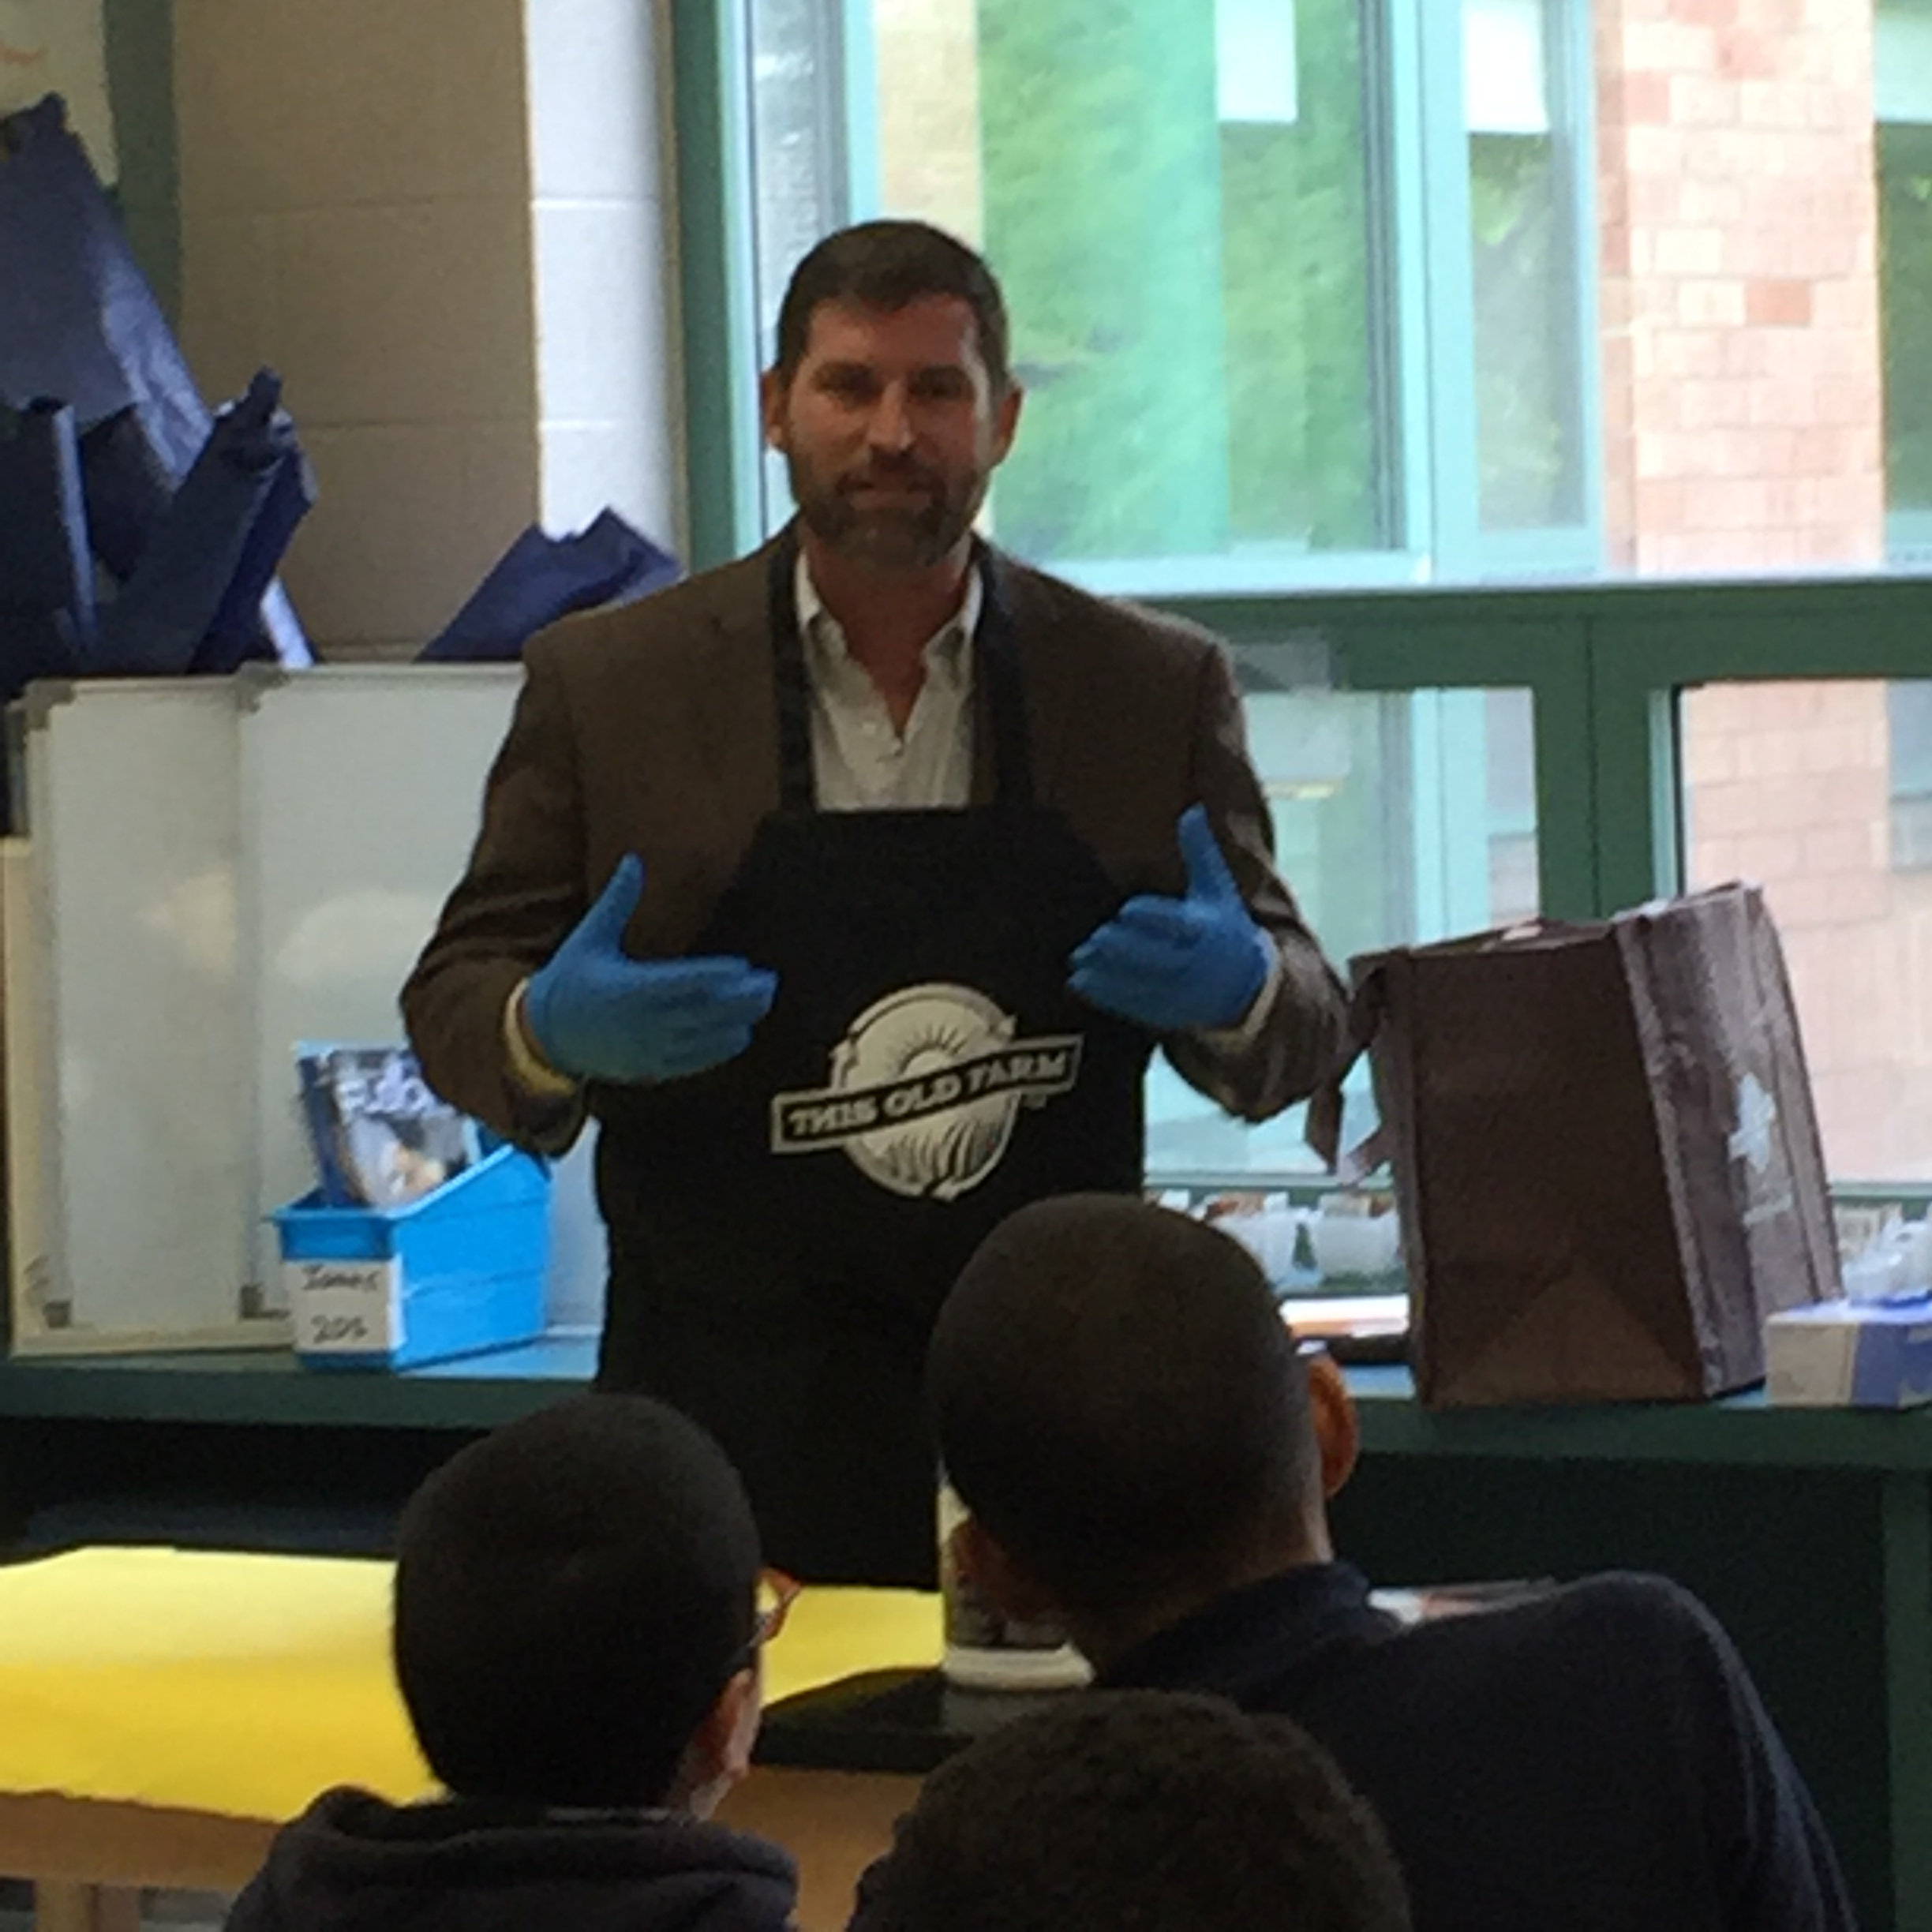  This Old Farm’s mission is to support the family farm through education, processing, and marketing locally raised meat and produce  Call 765 324 2161  info@thisoldfarminc.com | This Old Farm’s mission is to support the family farm through education, processing, and marketing locally raised meat and produce.  Call 765 324-2161  info@thisoldfarminc.com | This Old Farm’s mission is to support the family farm through education, processing, and marketing locally raised meat and produce.  Call 765 324-2161  info@thisoldfarminc.com

